FORMATS: FROM STONE TABLETS TO MODERNITY
Part 2: Now and later

In our last session we explored the writing found in ancient civilisations. I expressed sorrow for the loss of effort and knowledge that its destruction represents. I also questioned the role and values of affluent nations when “owning” or reconstructing treasures of the past.

We looked at the ancient belief that writing is so miraculous as to be considered directly God given. Last week I described the holy books of several religions as being written by the Finger of God, a literal belief still held by some today.

Now I have a question.

What do Humans do that other animals do not? They record. They record anything and everything, feelings, deeds, the instructions necessary to make or do anything, business details and ideas of all kinds. These recordings may be passed on to future generations and be in the form of drawing or text. This has been happening for a very long time.

It is surmised that during the Pleistocene Age, the first technologies of humans evolved, so speech and tool making seem to have occurred at the same time. Over a period around 1.8 million years ago, the brain grew to be one third larger than it had been before and the human face changed to be able to produce a greater range of sounds.

However a long time was to pass before we started to write. Anthropologists have found evidence that by 50,000 BCE people were drawing lines. It appears that early writing seems to have developed in various places independently. At least nine different systems have been identified globally so it is thought that while some societies had developed the need to record in writing, no one knows where the urge to write comes from. It seems to be innate. Children under the age of two take pleasure in making marks and adults idly doodle. Psychologists claim to find unconscious symbolism in these scribblings and some people claim to be able to write “automatically”. I am not one of them but if I could life would be easier.

Automatic writing is the alleged psychic ability, which allows a person to produce written words without consciously writing. The words are supposed to arise from subconscious, spiritual or supernatural sources and all you have to do is to clear your mind, find a quiet place, close your eyes and put pen to paper. Several French philosophers and writers worked this way using their very disciplined minds. I have tried but alas it doesn’t work for me.

On the other hand some people have hypergraphia, behaviour marked by the intense need to write. It is associated with temporal lobe changes and can produce a wide variety of styles of writing. Vincent Van Gogh, Fyodor Dostoevsky and maybe Robert Burns are said to have suffered from it. Lewis Carroll, wrote 98,000 letters, some backwards and some in rebus and he also may have had this condition.

In the case of Alvin Ridley, who was on trial in 1999 for the imprisonment and murder of his wife Virginia, her copious writing saved her husband from unjust imprisonment for a crime that he didn’t commit.

She had been secluded in her home for twenty-seven years and was unknown to anyone else in the town. Although it was the kind of place where everyone knew everyone else’s business, she was a recluse and an epileptic. So when she died it was deemed to be a suspicious death and Ridley was brought before the court. Fortunately for him it appears that Virginia was hypergraphic. She kept a long and precise diary, which provided evidence, that she had stayed housebound of her own free will. This evidence led to her husband’s acquittal.

Writing has not always been admired or accessible, universally. Recording comes after speaking in human development and may be regarded as technology.

New technology has always had its detractors, those who believe that it will eliminate or weaken part of society. But it is not the invention that creates change it is the emerging social needs. Often the old and the new coexist and just as television hasn’t killed radio, papyrus survived for centuries in the Mediterranean world, after paper was introduced.

Socrates made a case against writing by saying that the words themselves are not a complete representation of knowledge, but rather as words are to knowledge, pictures are to their subjects.

I feel that Socrates and Magritte may have had good dialogues together. Magritte is responsible for illustrating a body of work called “The Treachery of Images” and one of his famous works “This is Not a Pipe” demonstrates that an image, no matter how realistic, is not a reality.

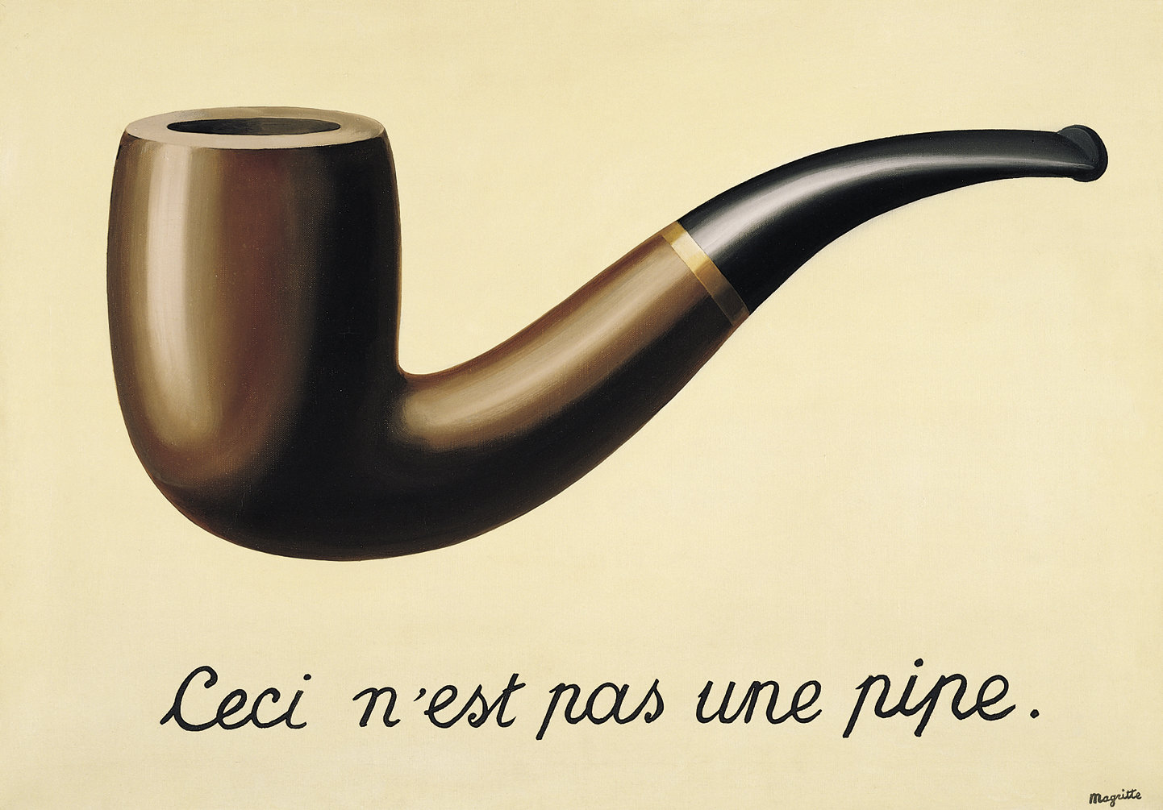

Anyone who has tried to book a holiday from an online illustration will understand the wisdom of Socrates and Magritte. No technology can replace experience.

Socrates believed that people who read a text only have a partial knowledge of the author’s meaning. Real knowledge can only be gathered by dialogue.

“Writing will create forgetfulness in the learners’ souls, because they will not use their memories. They will trust to the external written characters and not remember of themselves… they will be hearers of many things and will have learned nothing; they will appear to be omniscient and will generally know nothing; they will be tiresome company, having the show of wisdom without the reality”.

Does writing impede our ability to remember? I guess Hemingway had strong feelings about this when his wife lost a suitcase that contained all the existing copies of his current short stories. He said that he couldn’t recapture the process of rewriting them. “It’s useless”, he said. “Writing them, I felt all the emotion I had to feel about these things. I had put it all in and written and rewritten until it was all in them and all gone out of me”.

Socrates’ argument continues today as Bill Keller, a past executive editor of New York Times claims that, “we are outsourcing our brains to the cloud”. On the other hand Facebook and Twitter allow us to have more dialogues with people than at any other time in history.

Despite all argument against it, writing has survived, evolved and is more necessary than ever in our society. Passports, drivers’ licenses and social security cards provide proof of our very identity. Print surrounds us, follows us and loss of or denial of these papers can affect our lives dramatically.

It has recently been estimated that one in three people in Australia, have literacy skills low enough to make them vulnerable to unemployment and social exclusion. Literacy nowadays also refers to digital literacy. Jobs that once were less reliant on a literate workforce now need workers to be able to fill out occupational health and safety forms, use computers and have knowledge of industrial terminology.

To be illiterate has a high emotional cost. On a recent SBS “Insight” program, a guest speaking about this subject said, “You live with shame. I have for many years. Its something you just become accustomed to and, you know, that’s your way of life.”

On the other hand, there are people who feel that what they read is an important feature of their identity. Reading is regarded as such a marker of character that some people invest a great deal in cultivating identities as lovers of books. To have a library and to be knowledgeable about books implies privilege and education even in a digital age.

This is no new thing. For centuries the kings of Babylon and other centres of the East tried to build great libraries. In the 3rd century BCE, Ptolemy, a Macedonian Greek, came to rule Egypt. He set out to build the world’s greatest library in Alexandria, which was near a papyrus production centre. Every ship that called into the port was searched for books and any that were found, were copied and the original kept for the library. Any subject was wanted and three centuries later the library in Alexandria possessed perhaps 700,000 scrolls. The number is disputed but undeniably great.

Eumenes, ruler of the Greek city of Pergamum, also wanted to build a great library, but Ptolemy didn’t want a competitor so refused to export papyrus to him, thereby making it necessary to find an alternative writing material.

Eventually the people of Pergamum learnt how to soak animal hide in lime for ten days, scrape it and dry it. Young kid, lamb and gazelle were used and after being stretched and scraped, the hides were further smoothed with a stone. This new product is now called parchment after the city of origin and very fine parchment made from calfskin is called vellum.

Unlike papyrus, parchment could be made anywhere and it preserved well in a wide range of climates. But like papyrus, it was labour intensive to make and even more expensive. It could take as many as two hundred animals to make a single book. At first Roman officials only used it for expensive notebooks, but as it did not fray or split when folded, it was well suited for codices, early forms of books, now mainly associated with legal and accounting documents. It was easier to refer back to a previous page in a book than to search for something in the middle of a scroll, which requires rolling and unrolling and finally rerolling back to the beginning. It is estimated that Virgil’s work “Aeneid” would have taken twelve scrolls totalling one hundred and eight metres of length but could otherwise be contained in a single codex.

Finally, paper outstripped papyrus. It outperformed its competitors because of its practical properties. It is plentiful and durable, pliant, lightweight, inexpensive and versatile. Its uses are many. It can shield, disguise, protect, wipe, wrap, absorb, decorate and surprise us. From blotting paper to blue print, voting booths to promissory notes and from hats to houses it is easy to imagine “If all the world were paper and all the sea were ink” as the poem goes.

Exactly how paper was first invented is a mystery because it is different from the writing materials that came before it. It is made of cellulose fibres that are broken down and mixed with water until they are so diluted that they are barely visible. The resulting slush is then drained on a screen and the randomly woven fibres that are left become paper. Cellulose is a basic building block of plants and is therefore one of the most common organic compounds in the world. That is why so many different substances can be used for papermaking: wood, bark, grasses, cotton, silk and seaweed.

Paper is the first of what the Chinese call “the four great inventions”. According to legend, in 104 BCE, Cai Lun, the officer in charge of tools and weapons in the Han Court, reported to the Emperor that he had made paper from tree bark, hemp, rags of cloth and fishing nets. He was amply rewarded for his work but ended sadly. That is another story.

Soon after its invention, paper took off, so to speak and its use spread East and West until centuries later it had covered the world. From the first, it had multiple uses but its potential as writing material was immediately recognised and led to various ideas for its improvement, such as making it thinner and smoother and coating it with wax to make it less absorbent, more suitable for ink.

The Han Dynasty, which coincided with the Roman Empire, was a period of physical and cultural expansion. The Silk Road was established and dominated commerce in the region while a growth of ideas in philosophy, science and the first National Histories, created a great demand for writing materials. Over time, paper manufacture improved. New techniques meant faster methods and better, more specific production for a variety of uses.

Eventually paper was an essential element in Chinese life. It was used for clothing, kites, lanterns and fans. The Chinese invented paper cups and paper money. They also used imitation money in burial ceremonies, as they still do today, to thwart grave robbers. Marco Polo witnessed a cremation in which money and other valuables, including horses, camels and servants, were fashioned out of paper and placed on the funeral pyre. Better than the real thing, thought the servants.

In the fifth century Chinese culture spread to Korea and Japan. As well as paper making, it brought written language, Buddhism, Confucianism, calligraphy, painting and of course, bureaucracy. Every family was required to register births, marriages and deaths with two copies, one for the government and one for the family. The paper was of such high quality that records have survived into modern times without yellowing. Through these documents, some Japanese people can trace their family back for hundreds of years.

Japanese paper lasts because it has no acid content and doesn’t yellow. A twelve hundred- year old sheet looks fresh today. For about six centuries paper was exclusively Asian. China outlasted the Roman Empire.

Samarkand, on the Western end of the Silk Road and conquered by Alexander the Great in 329,was an important centre of commerce.

In the eighth century high quality linen rag paper from there, became famous in the Islamic world. Samarkand became the first paper centre outside East Asia.

About a hundred years after Mohammed’s lifetime Arabic writing was developed until it became one of the most beautiful scripts ever invented. By this time the Arabs were expanding their empire and needed paper for their bureaucracy and rich culture of arts, science and mathematics. They invented Algebra and made paper light enough for carrier pigeons. The word “ream” meaning “a bundle of five hundred sheets of paper” comes from Arabic. The Arabs introduced the process of paper making to present day Iraq, Syria, Egypt and Spain where Muslims controlled part of Europe for nine hundred years. Paper became essential to multiple forms of creative expression, allowing for an entirely new means of assisted thought, notation.

Arabic writing

At the height of the crusades, paper made its way into Europe by way of Muslim settlements in Spain and Sicily. There was widespread resistance to “heathen’ influence and also disbelief that paper was as durable as parchment. At first it was not used for official documents. However make its way, it did. Gradually Europeans grew interested and Sicily and Italy became steady customers. Finally European paper mills were established in Italy and Spain.

Fabriano, a town on the Castellano River was suitably water powered for paper manufacture and was the first verifiable site known in Italy. The nearby area was known for wool production and felt pressing. Felting mills were converted for paper production and this practice continued for centuries all over the world including America.

Fabriano papermakers were innovative. The drop hammer led to much cheaper paper. Moulds strung with more than a hundred feet of fine brass wire, woven into a single panel, made distinctive European paper. The producers also invented watermarks and continue to make them to this day. These have been used for dating, identifying and indicating levels of quality and to mark papers as official. They make counterfeiting a more difficult task. The first watermark identified was made in 1276.

From Italy this story now takes us to another time and another place. It is 1939 and raging bushfires have spared the Australian Paper mills at Maryvale in the heart of Gippsland, Victoria. This is fortunate because seventy per cent of its pulp production is to be used for the war effort. From our own eucalyptus trees we manufactured black out paper, security paper for passes and lab and blood serum filter papers. We made waterproof paper for wrapping food rations for troops in the South Pacific. And as well, we made board for aerial supply-containers called “storepedos”.

The War Museum in Canberra is filled with heart wrenching letters and documents from both World wars and we are reminded that from periods of disaster, new structures and inventions arise.

From this deep thought let’s move to some personal reminiscing. Believe it or not when I first started primary school I was handed a slate. I was happy when I graduated to a little blackboard and duster because slate pencil markings are faint and indefinite. At this time teachers were judged on their ability to create large eye-catching illustrations on the blackboard using coloured chalk. At the end of each term big boys from grade six were allowed to rub these out and create clouds of dust. For some reason the education department issued tiny little dusters. The boys would go outside to whack the grooved dusters with rulers and in the process always banged their fingers while entertaining the onlookers.

I hated writing lessons. From the beginning I struggled hard to tell the difference between “b” and “d”, to make letters with “tails’ and to do finger spacing. Worst of all was making letters sit on the lines. When I wrote without lines, all the letters wanted to slope to the bottom right hand corner. My writing never got better despite all the effort and practice. By the time I left school I could write like a doctor.

When I got to the higher grades I learned that you can lead a horse to water but a pencil must be lead. I had no idea at the time that in fact there is no lead in pencils, only graphite.

Sometime in the 1560’s a fierce storm in Cumberland, England uprooted a huge tree. Shepherds discovered a black substance clinging to its roots. This was used for marking their sheep and gradually its application for writing was developed. By the end of the sixteenth century graphite was well known for its superior line making qualities, the possibility of erasing it and the ability of drawing on top of it with ink. Pencils were first produced in Nuremberg, Germany in 1662.

During the Napoleonic Wars, France was unable to obtain pure graphite from England, leading to Nicholas Jacques Conte using a mixture of graphite and clay, which was formed into rods and fired. The balance of these ingredients led to a system of grading pencils according to their hardness and blackness.

In 1729 Benjamin Franklin advertised pencils for sale in his newspaper and George Washington used a three- inch pencil when he surveyed the Ohio Territory in 1762. Many noteworthy people have favoured pencils. Edison liked short ones that fitted into his waistcoat pocket, waiting for him to jot down ideas. It is said that Steinbeck went through sixty pencils a day when writing The Grapes of Wrath.

How many of you coveted Derwent pencils at school? You remember that girl with the plaits proudly showing off her Derwent seventy-twos in their special presentation box. They have been manufactured for one hundred and seventy- five years and are still going strong, with an extended range. You can visit Cumberland Pencil museum at Keswick, Cumbria if you are in the area.

Today fourteen billion pencils are manufactured annually, worldwide, from incense cedar, which is grown in managed forests rather than using less sustainable wood.

I’m not sure if this number includes the indelible pencils that are mandated for use at Italian elections or the blue, editing pencils, which bring despair to authors. Accountants recognise net loss by being in the red.

While on the topic of extra layers of meaning conveyed by the writing itself, we are all becoming familiar with different fonts, thanks to our use of computers. The names are exotic and interesting. They range from Avenir Black, Lucinda Bright to Zapfino.

Helvetica is a widely used typeface developed by the Swiss designers Max Miedinger and Eduard Hoffman. It was created in post war Europe and is the opposite of kitsch in its simplicity. In order to set the design apart from the past, superfluous ornamentation was stripped. The designers prized clarity, efficiency and cool understatement. As a result it is so widely used that it almost impossible to avoid. Helvetica reflects modern consumerism, as so many well-known companies have taken it up.

Now for the hotly debated question: “Is the pen mightier than the sword?” I can’t tell you the answer but there are some very pricy pens on the market. The Fulgor Nocturnus made by Tibaldi of Florence sold for 8million dollars in an auction in Shanghai in 2010. Its proportions are based on the Golden Ratio, which makes it aesthetically pleasing to the eye. It also helps, that it is encrusted with hundreds of black diamonds and rubies.

Another collectable pen created by Montegrappa, contains the oldest cognac in the world. The liquor, enclosed in a capsule, is from 1762 and has been officially entered into the Guinness Book of Records.

Strangely, goose quill pens remain part of the traditional life of the United States Supreme Court. Every lawyer who argues a case before the Court receives a quill pen, a custom continued since the 1800’s when they were accompanied with a full inkwell. Today as there are no inkwells provided, lawyers need to bring their own ballpoints.

That ballpoint may well be an inexpensive disposable Bic Cristal, or Biro, which is reportedly the most widely sold pen in the world. It was

The company’s first product and is shown as part of the permanent collection at the Museum of Modern Art in New York, acknowledged for its industrial design. Its hexagonal barrel mimics a wooden pencil and its transparency displays the ink level in the reservoir.

New technology has resulted in the development of the Fisher Space Pen. These combine more viscous ink with a pressurised ink reservoir that forces the ink towards the point. The rear end is sealed, eliminating evaporation and leakage and thus allows the pen to be used upside-down, in zero gravity environments and even under water. Astronauts have made use of the pens in outer space.

Famous 20th century artists such as Albert Giacometti, Francis Bacon and Andy Warhol have used ballpoints for precision or with mixed media works and this trend is continuing today.

Writing and drawing are ways of expressing our very identity. A hundred years ago, we used a typewriter. Today we use computers, while tomorrow who knows. Maybe an electronic device will convert our thoughts into written words directly. At any rate we have moved very far from one old form of visual communication, smoke signals. These are usually thought of in connection with Native Americans but they were also used in about 200BC to send messages along the Great Wall of China.

However when we speak of writing, the image mostly conjured up in our minds is that of a pen, so in that sense, perhaps the pen is mightier than the sword.

P.S. Here are some facts about the Silk Road

the ancient trade route

